**Visvesvaraya Technological University**

# Belagavi, Karnataka, 590 014.



## AICTE Activity Point Programme on

**“Local Tourism through Innovative Approaches”**

(Non-Credit Activity of 2 Weeks (80-90 hours))

Submitted in partial fulfillment of the requirements for the award of

**Bachelor of Engineering**

**in**

**Computer Science and Engineering**

**Semester III**

**Academic Year 2022-2023**

***Department of Computer Science & Engineering***

|  |  |  |
| --- | --- | --- |
|  | K. L. E. SOCIETY’SK. L. E. INSTITUTE OF TECHNOLOGY,Opp. Airport, Gokul, Hubballi-580 030Phone: 0836-2232681 Website: www.kleit.ac.in | **kle-logo** |

## AICTE Activity Point Programme on

**“Local Tourism Through Innovative Approaches”**

**List of the sites visited**

1. Rivers and Falls
2. Temples
3. Wildlife Santuary
4. Others

**Team Members**

* 2KE20CS006 Ananya V Melupparagimath
* 2KE20CS016 Banashankari Nagaling Kammar
* 2KE20CS024 Gayatri Gopal Gudi
* 2KE20CS038 Krutika R Soraganvi
* 2KE20CS058 Pranjali S Patil
* 2KE20CS071 Rashmi Karabasappagouda Biradar
* 2KE20CS072 Rohini Girish Navade
* 2KE20CS080 Sanjana R Deshpande
* 2KE20CS081 Sanjana Sampat Kadapatti

**CHAPTER 1**

**DANDELI**

**TOURISM**

**AIM**: Survey of Dandeli with address and details.

* 1. **RIVERS AND FALLS**
     1. **KALI RIVER**

The Kali River in Dandeli is one of the most beautiful places to visit in Karnataka because of the myriad activities that tourists can enjoy near it. It is not only the perfect place to spend an adventure-filled weekend but also an incredible sight-seeing spot in Karnataka, if you like spending time in the midst of nature.

It is known for its lush green jungles that fringe the banks of the river, as well as the dams that are located on the river to create the famous backwaters of Karnataka. The river starts at a small village called Kushavali in the mountain ranges of the Western Ghats and flows into the Supa Dam, where it is met by another famous river- Pandri. The river flows for a total distance of 184km before it finally meets the Arabian Sea.

The freshwater of the Kali River meanders through endless stretches of lush green vegetation over beautiful rock formations that make it ideal for sports like river rafting. The river, which is otherwise rather peaceful and quiet, suddenly transforms into a rush of white eddies as the river bed drops 10-20 feet near Dandeli, and then settles back into its peaceful pace.

There are several dams, forts, temples and forests along the river, but the adventure camp in Dandeli is one of the primary attractions of the Kali River. The camp organizes adventure sports and activities such as river rafting, canoeing, kayaking, birdwatching, trekking, hiking and nature walks, which makes for an ideal vacation for nature lovers and adventure enthusiasts.

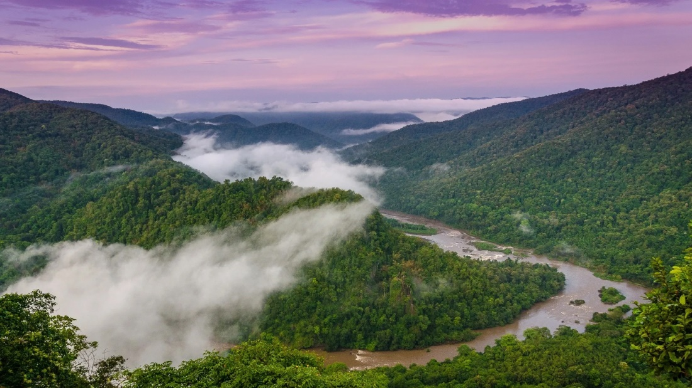

**LOCATION**:

|  |  |
| --- | --- |
| Physical characteristics | |
| Source | Diggi village, Karnataka |
| • location | Joida taluk |
| [Mouth](https://en.wikipedia.org/wiki/River_mouth) |  |
| • location | Arabian Sea, [India](https://en.wikipedia.org/wiki/India) |
| Length | 265 km (165 mi) |
| Discharge |  |
| • location | Karwar, India |

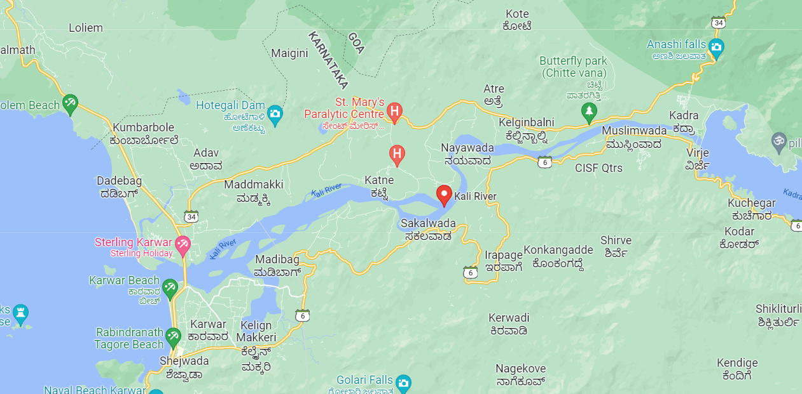

**1.1.2 MOULANGI AND MAGOD FALLS**

It is located near Molangi, with a panoramic landscape of thick and dense forest, the Molangi Falls is an ideal picnic spot and best for a rejuvenating visit to Dandeli. A visual delight for visitors this popular fall is nestled amidst thick bamboo trees and steep rocks making it ideal for trekkers and climbers.

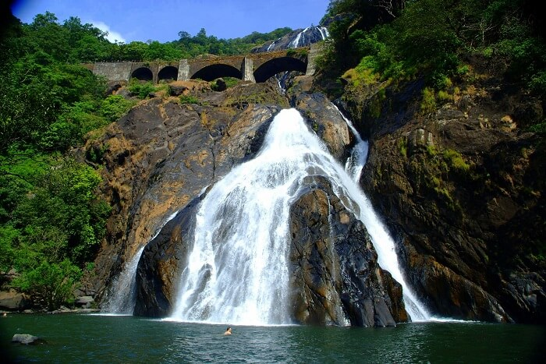

Magod Falls is situated near to the famous sunset point of this region named JenukalluGudda. One will find a beautiful lake named Kawadikre, on the way to Magod Falls. This lake is spread within an area of 60 acres. Magod Falls is a mandatory tourist attraction of DANDELI TOUR PACKAGE. There is less crowd in this area, and this place appears lonely after 5 pm. So, visitors usually arrive at Magod Falls during the visiting hours. This place has a magnificent view of the waterfall that has made Magod Falls one of the best places of Dandeli tourism.

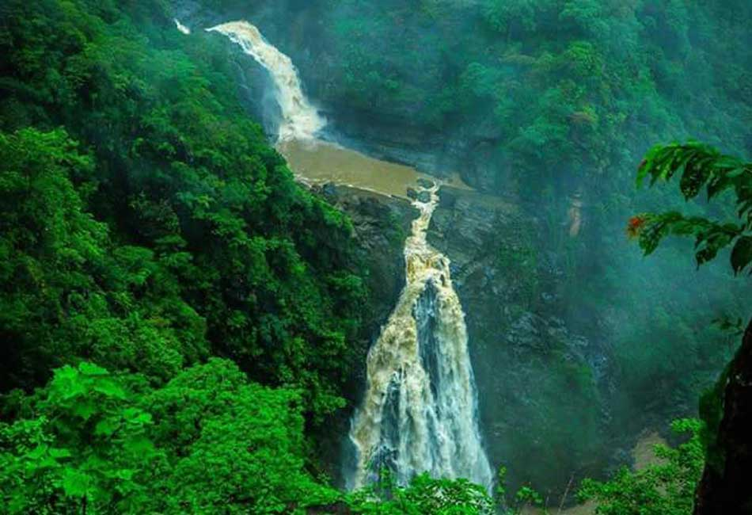

**Location:** It is located near Molangi in Karnataka.

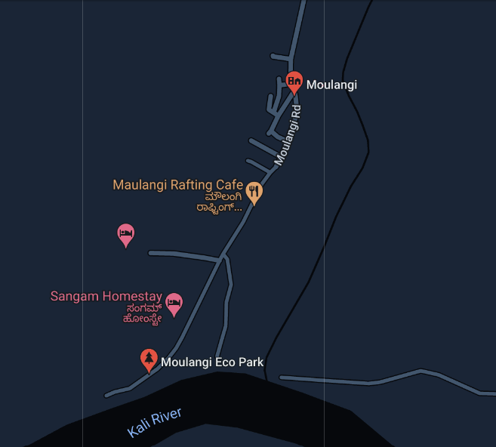

**Best Time to visit:** It is best visited during the monsoon months of the year.

* 1. **TEMPLES**
     1. **SRI MALLIKARJUNA TEMPLE**

Sri Mallikarjuna Temple is believed to be the oldest temple in the state. In fact, a stone inscription states that it was built in 1144 on land donated by King Jayakesha. The temple is of immense religious significance and the marvellous Kadamba style architecture also attracts tourists in large numbers. The temple is notable not only for its spiritual significance but also for its architectural brilliance. Some of the most notable features of Sri Mallikarjuna Temple is the ‘Navarang mantap’ places inside the sanctum sanctorum and the dome which is shaped in popular Kadamba style.

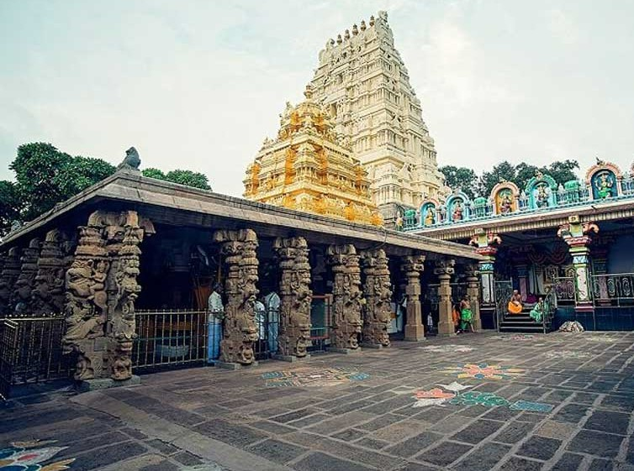

**Location:** Ganesh Gudi, Uttara Kannada District, Karnataka

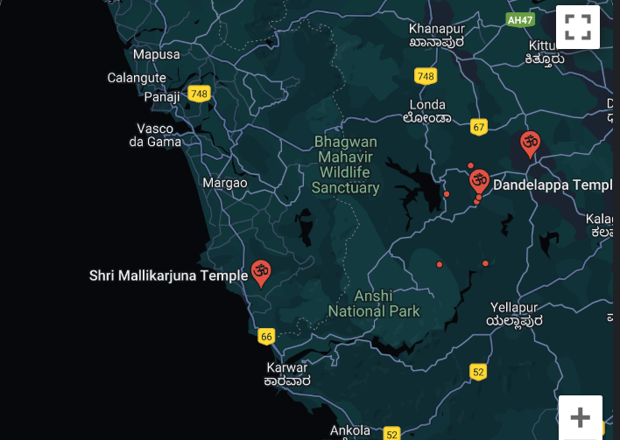

**Best Time to visit:** The winter season from October to February is great to visit Sri Mallikarjuna Temple

**Entry fee:** None

**Timings:** One can visit here from 6:00 am to 7:00 pm every day of the week

* + 1. **ULAVI TEMPLE**

It is an important tourist attraction in Dandeli. It is considered a very sacred place for the Lingayat community with the samadhi of Channabasavanna, a revered 12th century Lingayat saint

The temple is surrounded by a blanket of evergreen forests and the Western Ghats adorn the landscape. These forests also happen to a natural habitat for many rare wild animals like cheetah, cobras, tigers, elephants etc.

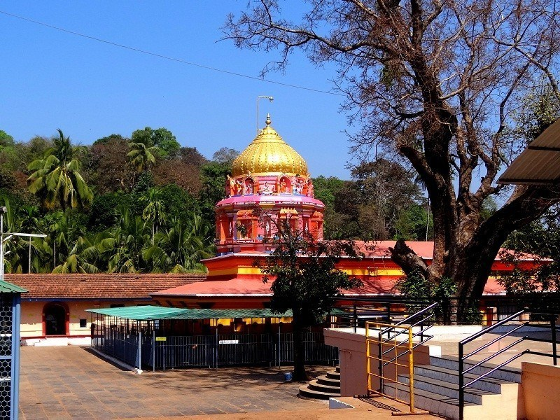

**Location:** Ulavi Temple is located in the Uttara Kannada district of Karnataka

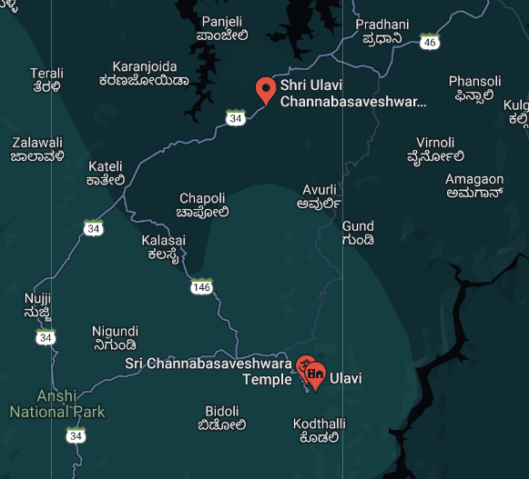

**Best Time to visit:** Ulavi Temple can be visited by the tourists throughout the year

**Entry fee:** None

**Timings:** The timings at Ulavi Temple are from 8:00 am to 6:00 pm

# Dandelappa Temple

 Dandellapa Temple is known to be as the one of the most auspicious places to visit in Dandeli. Located across the belt of Maland, Dandelappa Temple is replete with mesmerising natural beauty making the landscape a visual treat for the eyes.

It is also one of the oldest temples in Dandeli where the people come to seek the blessings of Lord Dandelappa to whom this temple is dedicated. The local deity Dandelappa is considered to be a beloved figure among the locals in Dandeli and it is interesting to note that the name Dandeli comes after Dandellapa.

It is said that those who worship at Dandelappa temple get their wishes fulfilled. The temple is a great tourist spot for its spiritual ambience and also offers an insight into the history and society of Dandeli.

**Location:** Ganesh Gudi, Uttara Kannada, Karnataka

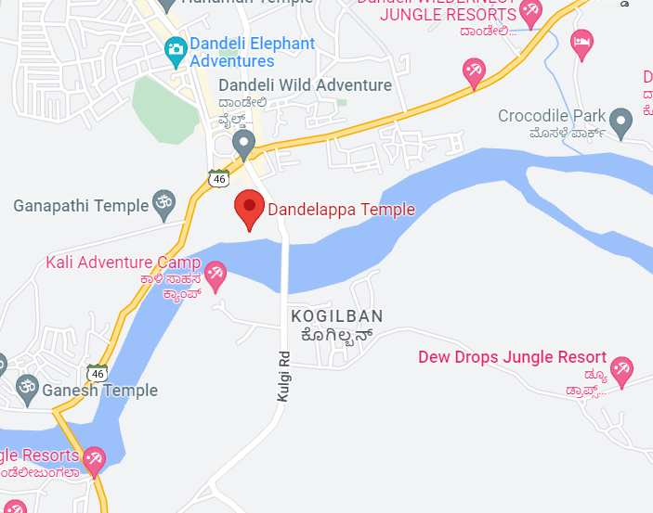

**Best Time to visit:** Tourists here can visit the temple anytime throughout the year. However, the most preferred time is from October to February

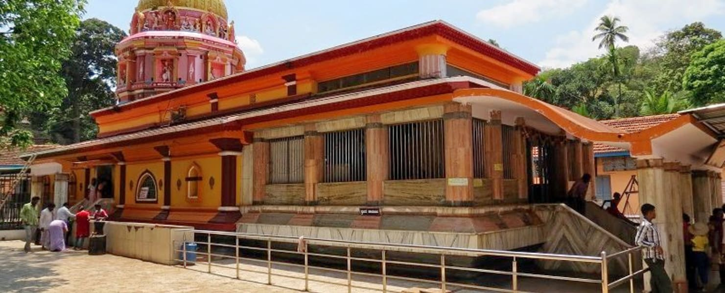

* 1. **WILDLIFE SANTUARY**

For fans of wildlife tourism, Dandeli Wildlife Sanctuary is a wonderful getaway to enjoy some time in the company of lush green forests and wild animals. Located on the Western Ghats, this sanctuary is acclaimed for having a range of diverse flora and fauna. It is amongst the few places to visit in Dandeli that boasts of an incredible landscape which is filled with river valleys, verdant hills and scenic beauty. Other than, tourists here can look forward to catch a glimpse of animals like black panthers, elephants, crocodiles and birds like Malabar pied hornbill, golden backed woodpecker, white breasted kingfisher etc.

Dandeli Wildlife Sanctuary is a birdwatchers paradise, housing nearly 200 species of birds most famous for the great hornbill (great Indian hornbill or great pied hornbill) and the Malabar pied hornbill. It is also the only known tiger reserve in India to report frequent sightings of the elusive black panther.

Dandeli is a natural habitat for wildlife, including tigers, leopards, black panthers, elephants, gaur, deer, antelopes, and bears.It is the second largest wildlife sanctuary in Karnataka[5] and was designated as a tiger reserve in 2007.The jungle is also home to several varieties of reptiles and almost 300 varieties of birds.The rapid expansion of industry has raised fears of ecological damage to the area, and local volunteer groups have formed to address the issue.

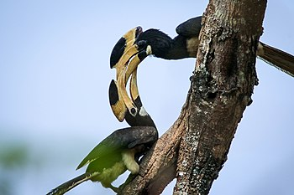 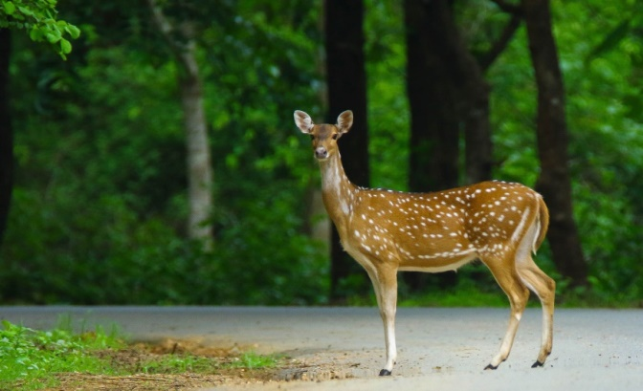

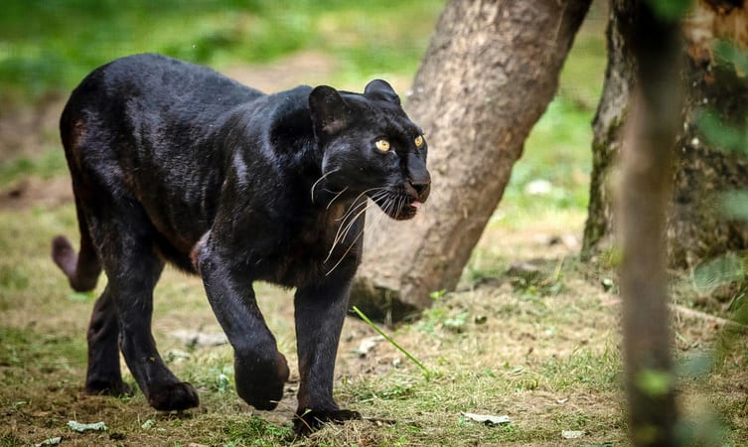

LOCATION:

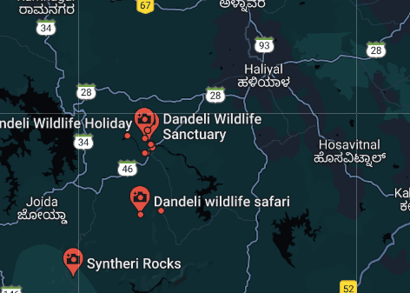

# Anshi National Park

Anshi National Park, in Uttara Kannada district of Karnataka, is one of the most beautiful parks in India. Located amid the majestic Western Ghats, it has well acclaimed flora and fauna. It is part of the Dandeli wildlife sanctuary and is situated on the highway of Kanwar-Londa. Located on the river Kali, the park spans across an area of 340 square km.

It is situated at a height of 200 m to 925 m above sea level. The park experiences an average of 2500 m of heavy rainfall. The temperature in the region varies between 40 degrees C and 10 degrees C.

The government of India has declared the park as a protected reserve forest, renaming it as Kali Tiger Reserve. One of the main attractions in the park is the rare Black Panther. The park hosts the dense deciduous forests and evergreen rain forests.

The Park is the home for innumerable species of plants and trees, some of which have been declared as endangered by the World Wide Fund for Nature. The prominent trees which dominate the forest are Teak, Oak, Bamboo, Eucalyptus, Lantana, Jamba, Tamarind, Bintangur, Bauhinia, Blackboard tree, Flacourtia Montana and so on.

The fauna inside the park is a delight for wildlife photographers. The forest is well known for the famous Black Panther, the elephants, and the tigers. The other animals that dominate the forest are sambar deer, wild boar, bison, sloth, barking deer, leopard, jackal, wild cat, bonnet macaque and langur.

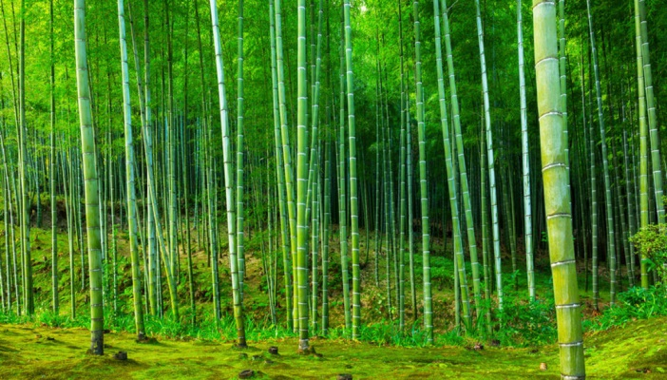 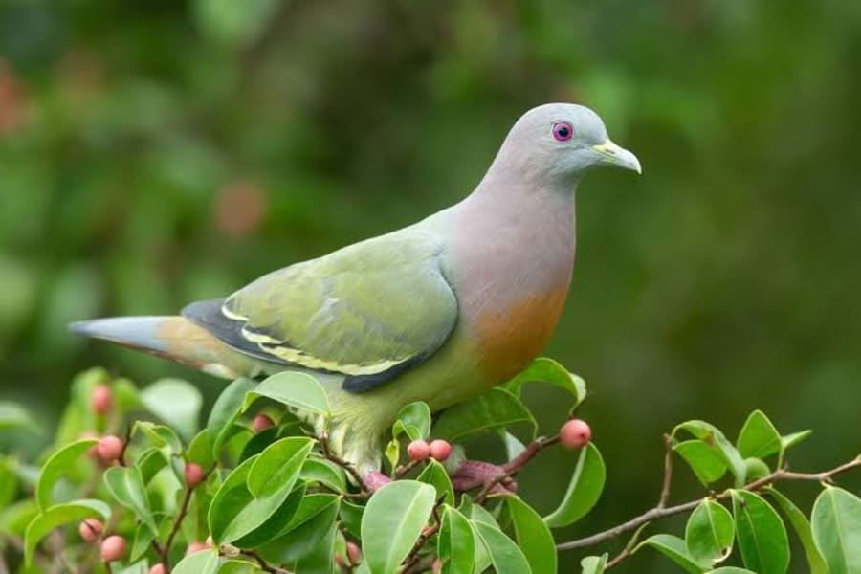

LOCATION:

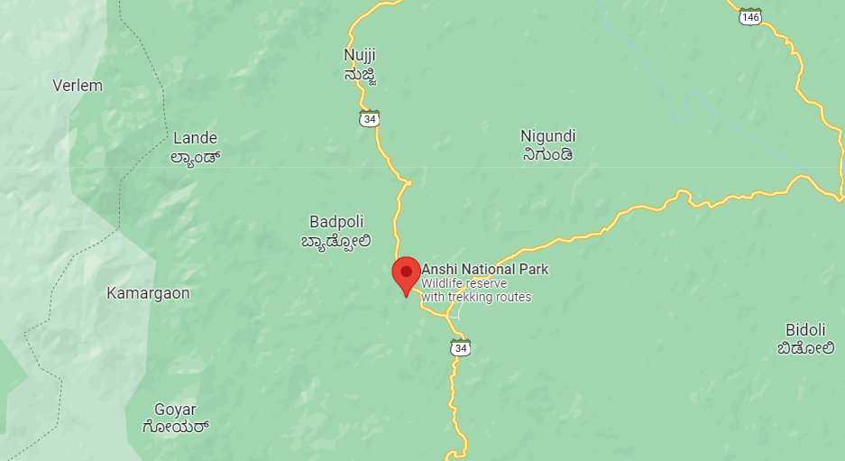

* 1. **ACTIVITIES**

**1.5 OTHERS**

**1.5.1 SUPA DAM**

Located in Joida Taluk of Dandeli, the Supa Dam marks its reputation as a hotspot for the travelers of Dandeli. Since ages, the Supa Dam has been acknowledged as one of the leading hydroelectric power generation plants in the town. There’s a tremendous mythological belief which names this dam as Supa Dam. It has been named after Suparulu, who once was praised as the God of Forests by the locals staying nearby. As the route that leads you to the exact location of the Supa Dam trespasses thick jungles, listen to the gushing sound made by the water of the rivers that flow there.

**Location:**  
Supa Dam, Ganeshgudi, Joida Taluk, Dandeli.

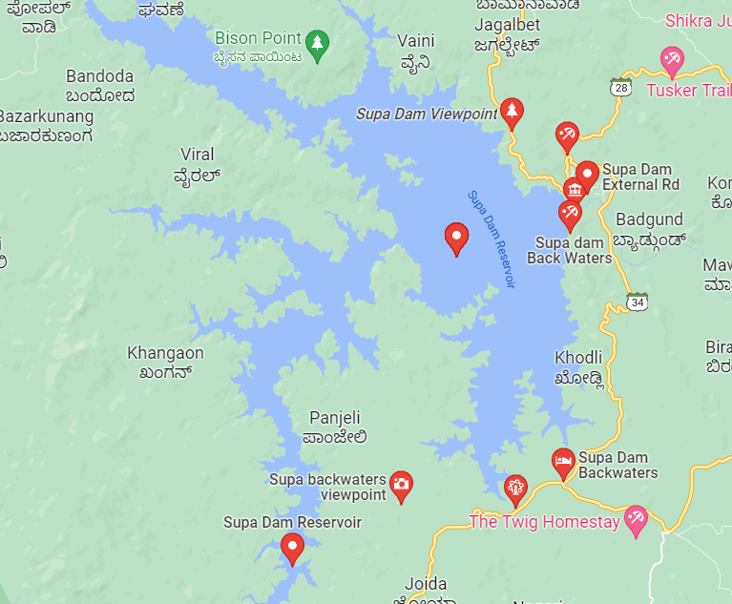

**Entry Fee:**  
You do not need to pay any entry fee to seek easy access to the Supa Dam of Dandeli.  
  
**Height:**  
The dam of Supa at the Dandeli has a height of around 101 meters from the ground level.

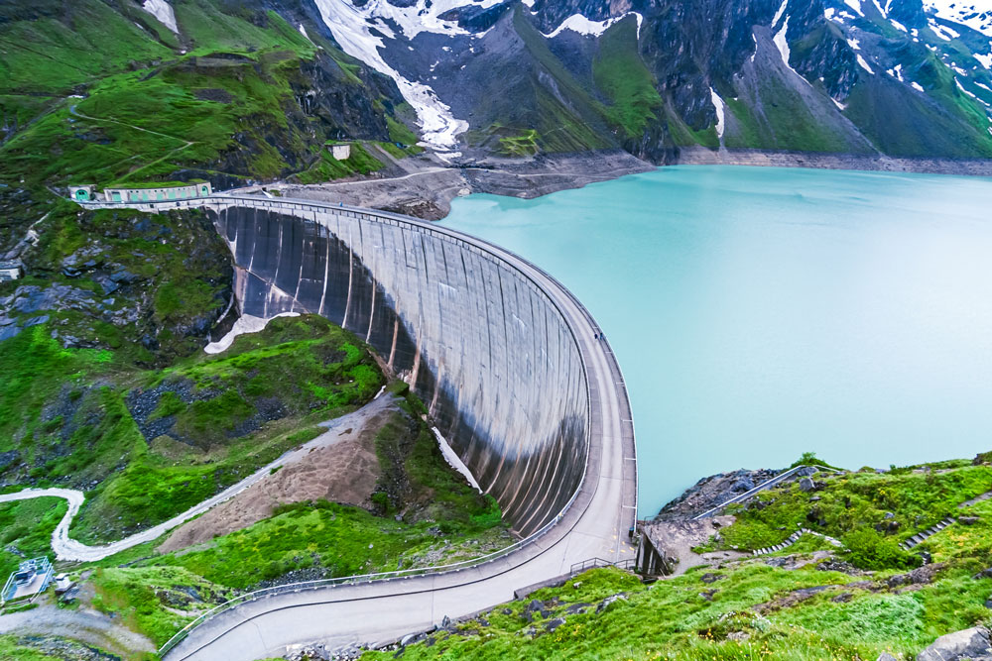

**1.5.2 SYNTHERI ROCKS**

Syntheric Rocks is one of the most scenic tourist attractions in Delhi and offers a wonderful time for the visitors with its beautiful landscape. Located in the centre of Dandeli Wildlife Sanctuary, Syntheri Rocks boasts of spectacular natural beauty that is made up of volcanic rocks with the River Kaneri passing by its side.

Named after the English lady Ms Cinthera who discovered these caves, Syntheri Rocks are today known for its marvellous topography. It is an idyllic spot for those who like to capture the best scenes in their cameras and those who are looking to retreat in places abound by nature. It is one of the top tourist places to visit in Dandeli for getting a taste of adventure in the most splendid nature.

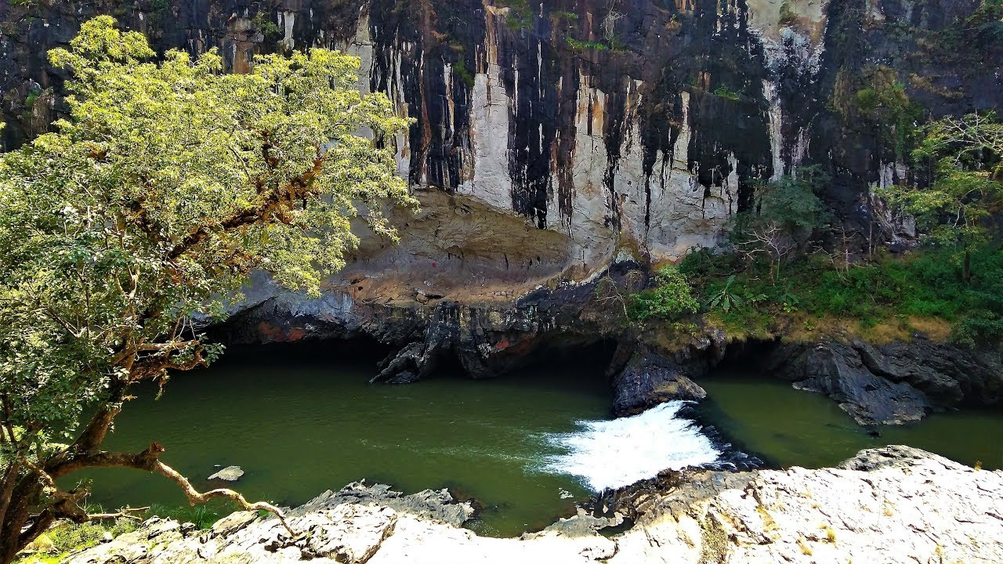

**Location:** Syntheri Rocks, Dandeli Wildife Sanctuary, Uttara Kannada,Karnataka

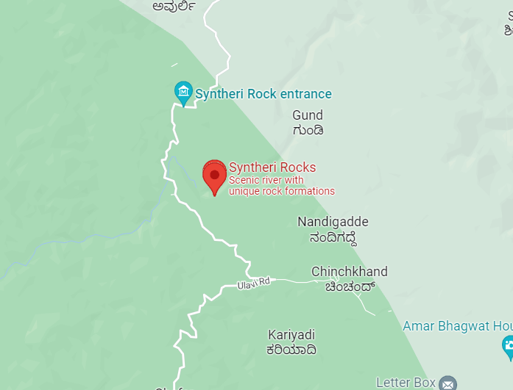

**Best Time to visit:** October to March is the most pleasant time for the tourists to go to Syntheri Rocks

**Entry fee:** After getting a permission from the Forest Department to reach here, tourists need to pay an entry fee of INR 20/ USD 0.30 per person

**Timings:** It is open from 8:30 am to 5:00 for the tourists